**Spread the joy:**

**How bias for happy facial emotions translates into daily life affect dynamics**

**Detailed description of the facial emotion identification morph task**

We used a morph task developed at Radboud University Nijmegen, the Netherlands (Lodder, Scholte, Goossens, Engels, & Verhagen, 2015; Vrijen et al., 2016). Stimuli consisted of movie clips that lasted 10 seconds and contained 100 frames depicting the gradual change (i.e., ‘morph’) from a neutral facial expression to one of four full intensity emotional expressions: happiness, sadness, anger or fear (see Figure s1 for examples). The movies had a resolution of 256 x 256 pixels, and were created with FaceMorpher (Luxand Inc., Alexandria, VA, USA) from high quality pictures of six different actors (50% females) from the Radboud Faces Database (Langner et al., 2010). Pictures were cropped with an ovoid frame and converted to grey scale to avoid distracting external cues. Four movies were created of each actor, that is, one for each emotional expression. The original task contained 48 movie clips, that is, twelve per facial emotion, whereas we used a shortened version of 24 movie clips, that is, six for each emotion. A previous study in a large sample of young adults (Vrijen et al., 2016) indicated that the emotion identification patterns and reaction times for the shortened version are highly similar to the ones reported for the original 48-video-clip version of the morph task (Lodder et al., 2015).

The morph task was programmed in Inquisit 4 (Millisecond, Seattle, USA). The task started with the instruction that participants were about to see movies of faces gradually changing from neutral to emotional expressions. Participants were asked to press the space bar as soon as they were able to identify the emotion. After pressing the spacebar the stimulus movie disappeared and participants indicated the emotion they identified by clicking on one of the four emotion labels. After clicking ‘next’ a fixation cross appeared in the middle of the screen for 500 ms, followed by a new stimulus. The order of the movie clips was randomized for each participant separately. Before the start of the actual task participants were shown a complete 10-s example movie, followed by two practice trials. After the practice trials the instructions were repeated, followed by the actual task consisting of 24 trials.

For each participant the mean reaction time (RT) of correctly identified trials was calculated per emotion, resulting in RT Happy, RT Sad, RT Angry and RT Fearful. RTs were calculated only if participants correctly identified at least four out of six movie clips of a specific emotion, otherwise they were considered unreliable. This resulted in 2 missing values for RT Sad, 1 for RT Angry and 2 for RT Fear at T0; and 1 missing value for RT Sad, 2 for RT Angry and 2 for RT Fear at T2. None of the remaining RT scores reached the maximum value of 10,000 ms which indicates that the participants always pressed the spacebar before the movie clips stopped.

As mentioned in our description of the selection procedure of the high and low happy bias groups, we calculated happy bias scores for each participant by taking the average of their RT scores on the other emotions (RT Sad, RT Angry and RT Fearful) and dividing it by RT Happy. Based on these happy bias scores we selected participants for the high happy bias group and the low happy bias group according to the procedures described in the selection procedure of the high and low happy bias groups.

There is no gold standard for measuring facial emotion identification, or, more specifically, happy bias. We used a morph task because this enabled us to assess the identification of more subtle traces of emotions, which is assumed to give a more ecologically valid perspective than static full intensity facial emotion identification tasks, as in daily life static full intensity facial emotions are quite rare. Empirical studies have suggested that affective biases can be assessed by means of a morph task. Individuals with affective problems showed a lower sensitivity to happy facial emotions in a study in which a morph task largely similar to ours was used (Joormann & Gotlib, 2006). Using the same morph task as the one used in the present study we found that lower sensitivity to happy facial emotions was associated with psychiatric problems in a large sample of young adults (*N*=2577) (Vrijen et al., 2016).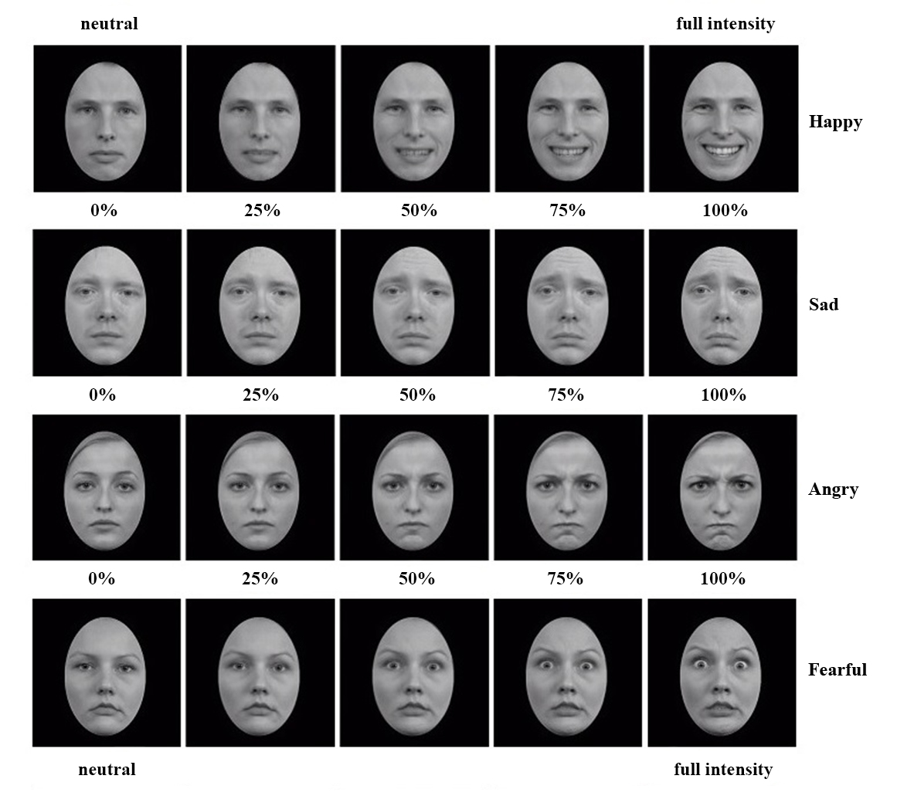

*Figure s1.* Examples of the morphs from neutral (0%) to full intensity (100%) emotional expressions. Five of in total hundred frames of the movie clips are presented in this figure.

**References**

Joormann, J., & Gotlib, I. H. (2006). Is this happiness I see? Biases in the identification of emotional facial expressions in depression and social phobia. *Journal of Abnormal Psychology*, *115*(4), 705–714. https://doi.org/10.1037/0021-843X.115.4.705

Lodder, G. M. A., Scholte, R. H. J., Goossens, L., Engels, R. C. M. E., & Verhagen, M. (2015). Loneliness and the social monitoring system: Emotion recognition and eye gaze in a real-life conversation. *British Journal of Psychology*, *107*, 135–153. https://doi.org/10.1111/bjop.12131

Vrijen, C., Hartman, C. A., Lodder, G. M. A., Verhagen, M., de Jonge, P., & Oldehinkel, A. J. (2016). Lower Sensitivity to Happy and Angry Facial Emotions in Young Adults with Psychiatric Problems. *Frontiers in Psychology*, *7*. https://doi.org/10.3389/fpsyg.2016.01797